**Mini Project Data Mart**

**Business Need:**

a. What are the count of correspondences and cost of communication

per sender per subject per institution per client per year/month?

b. What is the correlation between month, subject and institute

|  |  |  |
| --- | --- | --- |
| **Measure** | **OLTP Fields** | **Data Type** |
| Cost | Rejected flag | Int |

Figure 1. Finalized measures for the Mini Project Data Mart

|  |  |  |  |
| --- | --- | --- | --- |
| **Dimension** | **OLTP Fields** | **Data Type** | **Parent Dimension** |
| Dim_Client | Dim_Client | Int | None |
| Dim_Date | Dim_Date | Int | None |
| Dim_Subject | Dim_Subject | Int | None |
| Dim_Institution | Dim_Institution | Int | None |
| Dim_Sender | Dim_Sender | Int | None |

Figure 2. Finalized dimensions and hierarchies for the Mini Project Data Mart

|  |  |
| --- | --- |
| **Mini_Project_Fact** | |
| **Field Name** | **Data Type** |
| Cost | Int |

Figure 3. The Mini Project Data Mart schema with measures in a fact table

|  |  |
| --- | --- |
| **Mini_Project_Fact** | |
| **Field Name** | **Data Type** |
| Fact_ID (PK) | Varchar(500) |
| Cost | Int |

|  |  |
| --- | --- |
| **Dim_Client** | |
| **Field Name** | **Data Type** |
| Client_Num (PK) | Varchar(500) |
| EN_Client | Varchar(500) |
| FN_Client | Varchar(500) |

|  |  |
| --- | --- |
| **Dim_Date** | |
| **Field Name** | **Data Type** |
| Date_ID (PK) | Varchar(500) |
| Reg_Num | Varchar(500) |
| Reg_LN | Varchar(500) |
| Reg_FN | Varchar(500) |
| Comm_Date | Datetime |
| Cert_Date | Datetime |
| Post_Date | Datetime |

|  |  |
| --- | --- |
| **Dim_Subject** | |
| **Field Name** | **Data Type** |
| Subject_ID (PK) | Varchar(500) |
| Subj_Comm | Varchar(500) |

|  |  |
| --- | --- |
| **Dim_Institution** | |
| **Field Name** | **Data Type** |
| Institution_ID (PK) | Varchar(500) |
| Institution | Varchar(500) |

|  |  |
| --- | --- |
| **Dim_Sender** | |
| **Field Name** | **Data Type** |
| Sender_ID (PK) | Varchar(500) |
| Sender_LN | Varchar(500) |
| Sender_FN | Varchar(500) |
| Sender_PosTit | Varchar(500) |
| Sender_Branch | Varchar(500) |

Figure 4. The Mini Project Data Mart schema with dimension tables added

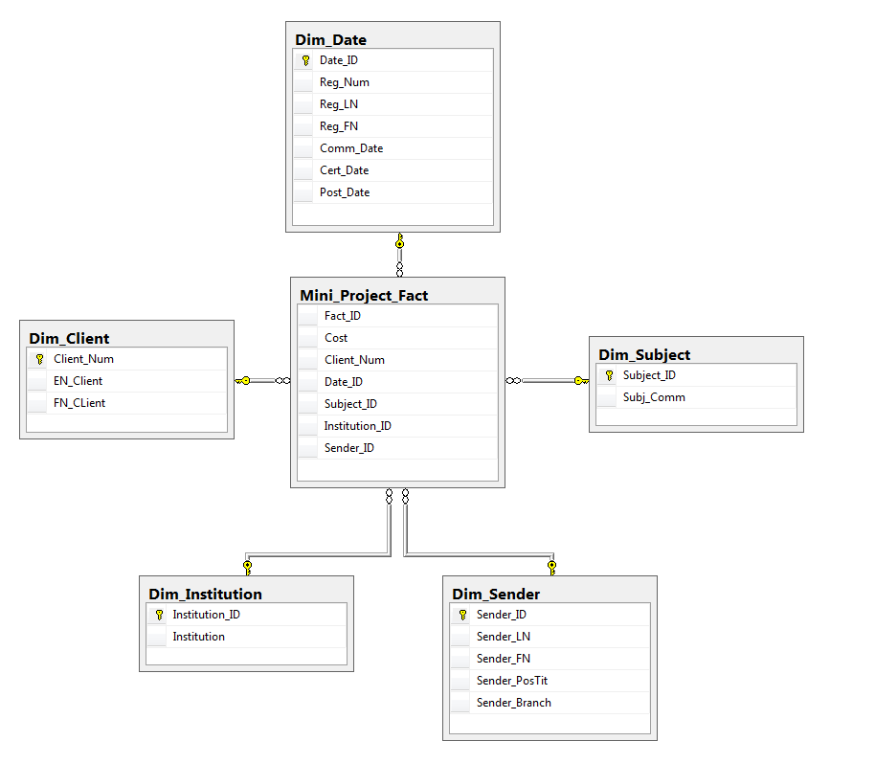

Figure 5. The Mini Project Data Mart Diagram

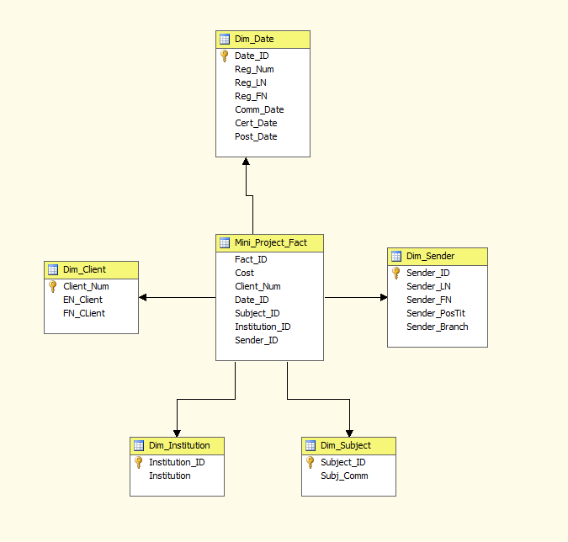

Figure 6. The Mini Project Data Mart Cube

Master.dtsx

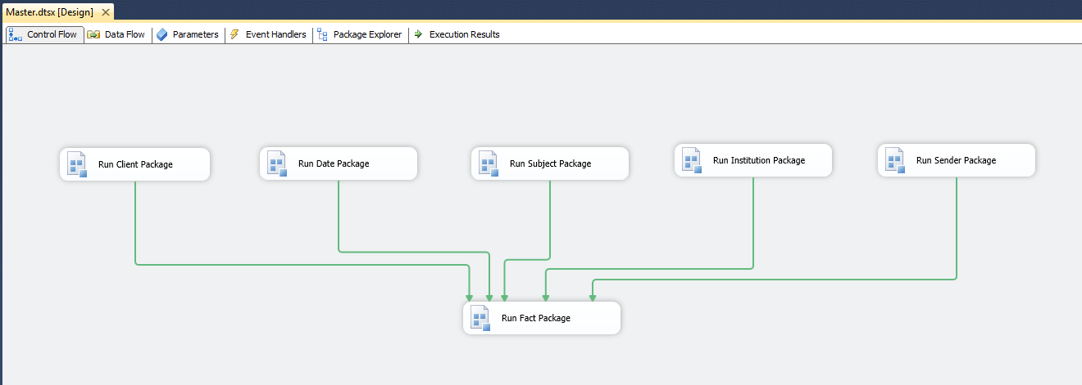

Client.dtsx

A Snapshot of the SSIS package DataFlow

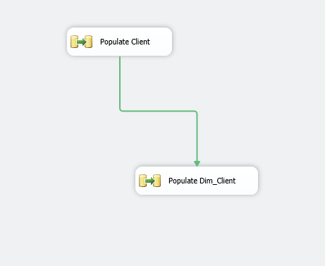

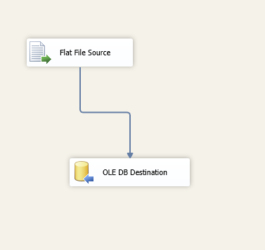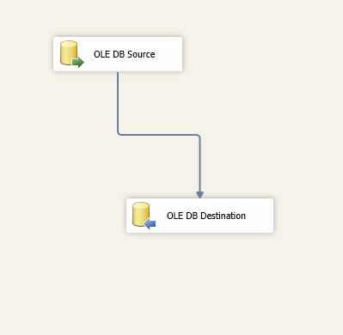

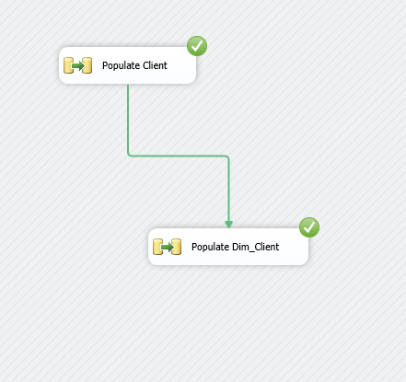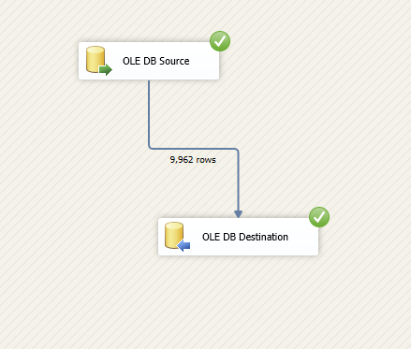

A snapshot of DataFlow MetaData showing the types and sizes of data in SSIS

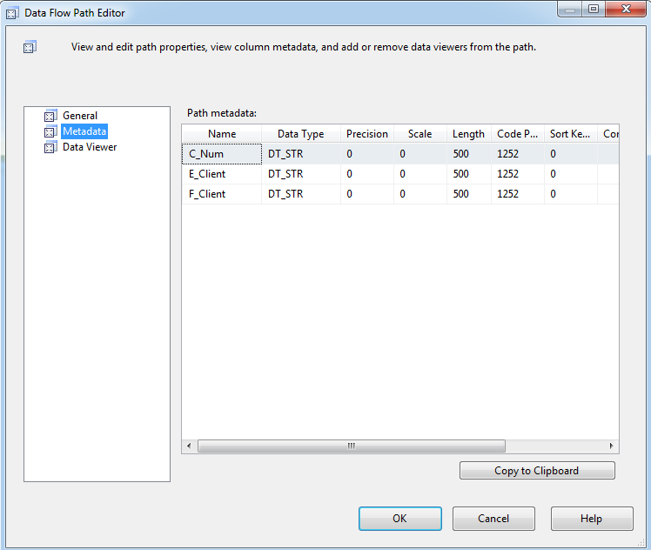

A snapshot of table design view showing the types and sizes of columns in SQL Server

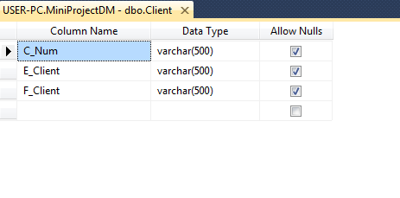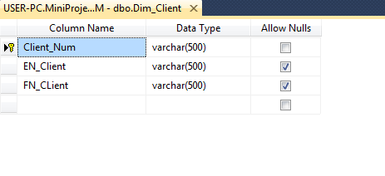

A snapshot of the result of the "Select * from ..." query from your table after successfully running the SSIS package

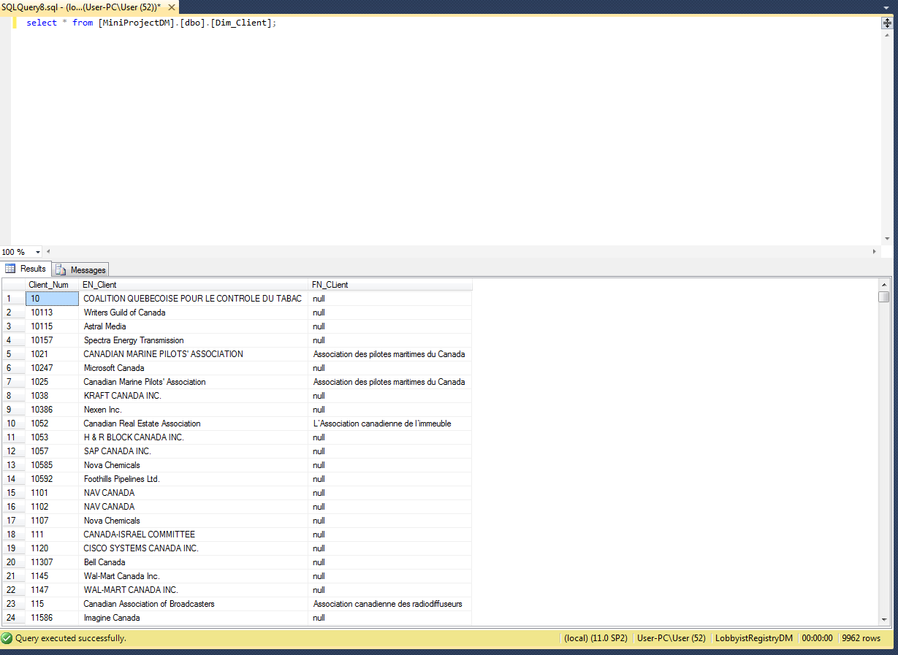

Data.dtsx

A Snapshot of the SSIS package DataFlow

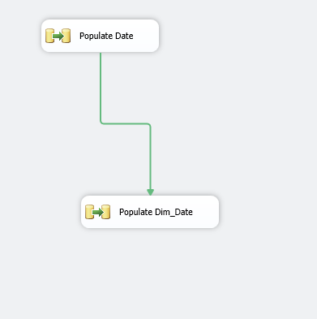

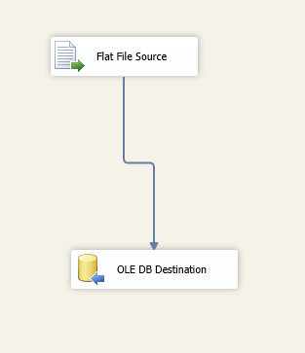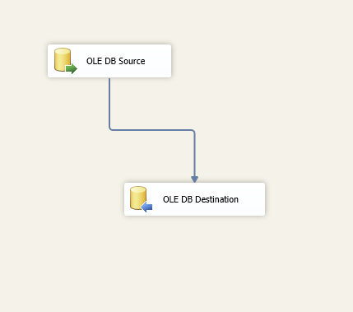

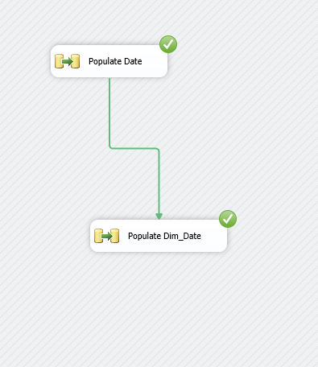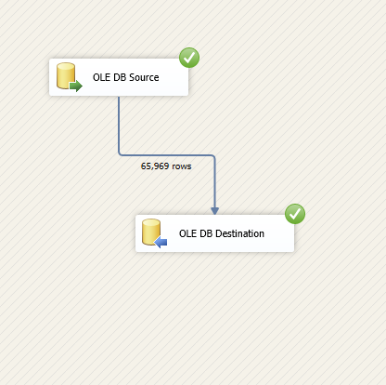

A snapshot of DataFlow MetaData showing the types and sizes of data in SSIS

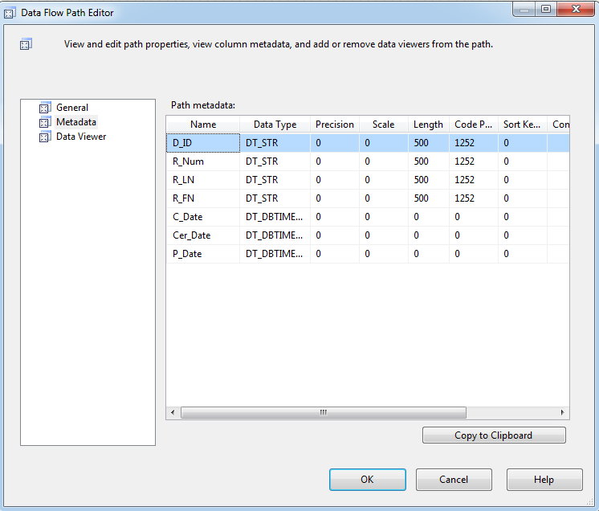

A snapshot of table design view showing the types and sizes of columns in SQL Server

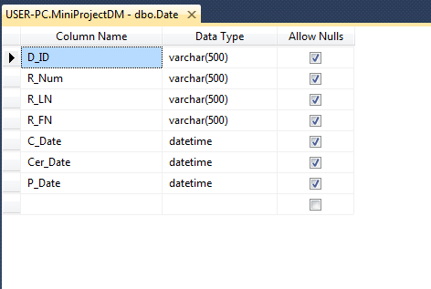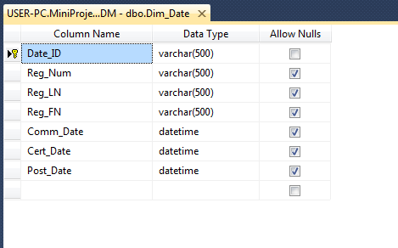

A snapshot of the result of the "Select * from ..." query from your table after successfully running the SSIS package

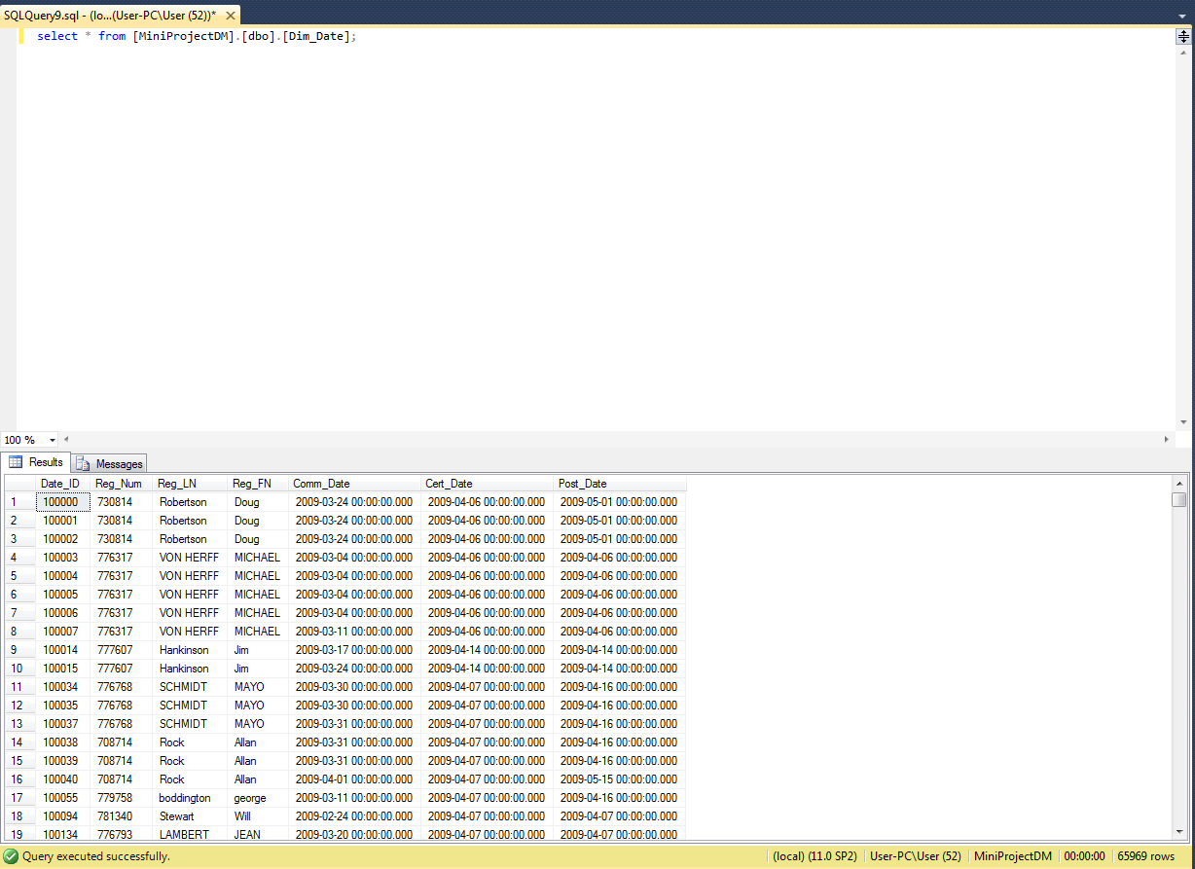

Subject.dtsx

A Snapshot of the SSIS package DataFlow

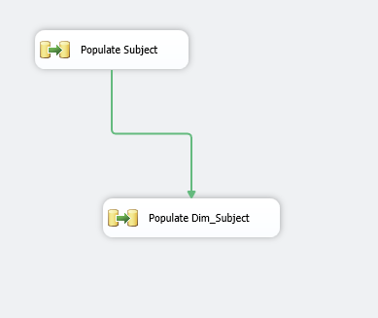

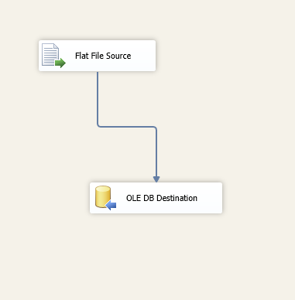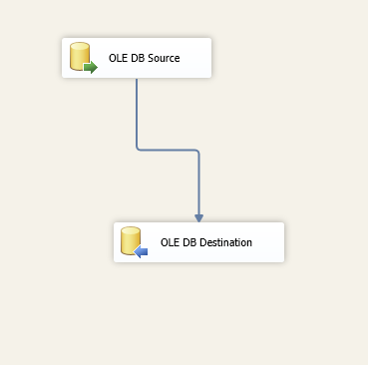

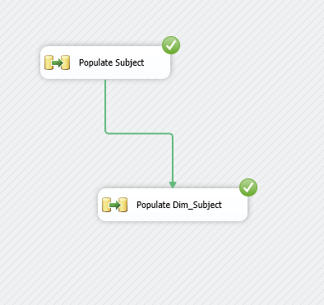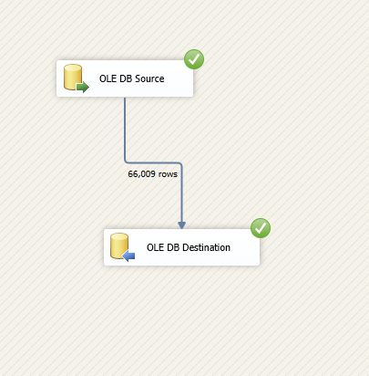

A snapshot of DataFlow MetaData showing the types and sizes of data in SSIS

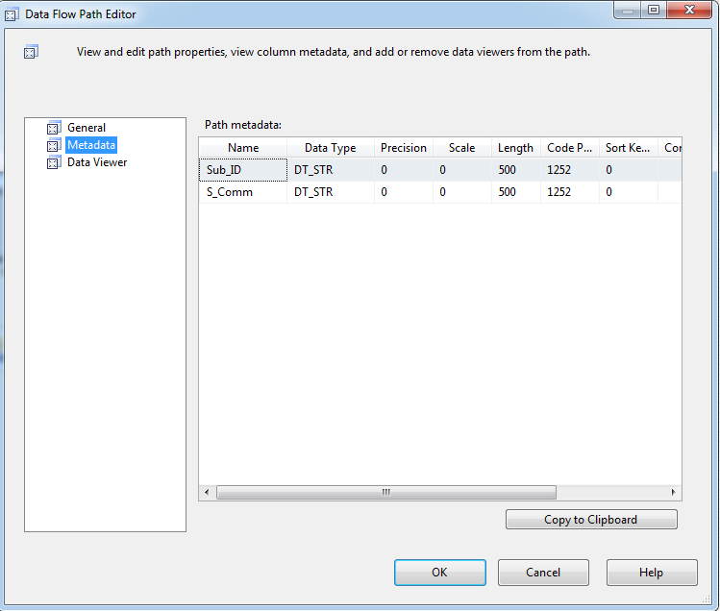

A snapshot of table design view showing the types and sizes of columns in SQL Server

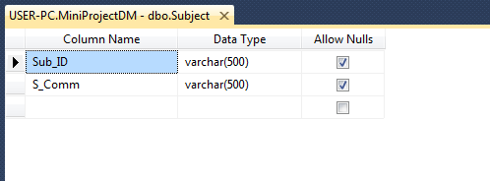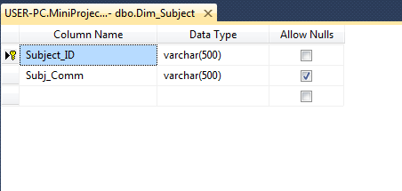

A snapshot of the result of the "Select * from ..." query from your table after successfully running the SSIS package

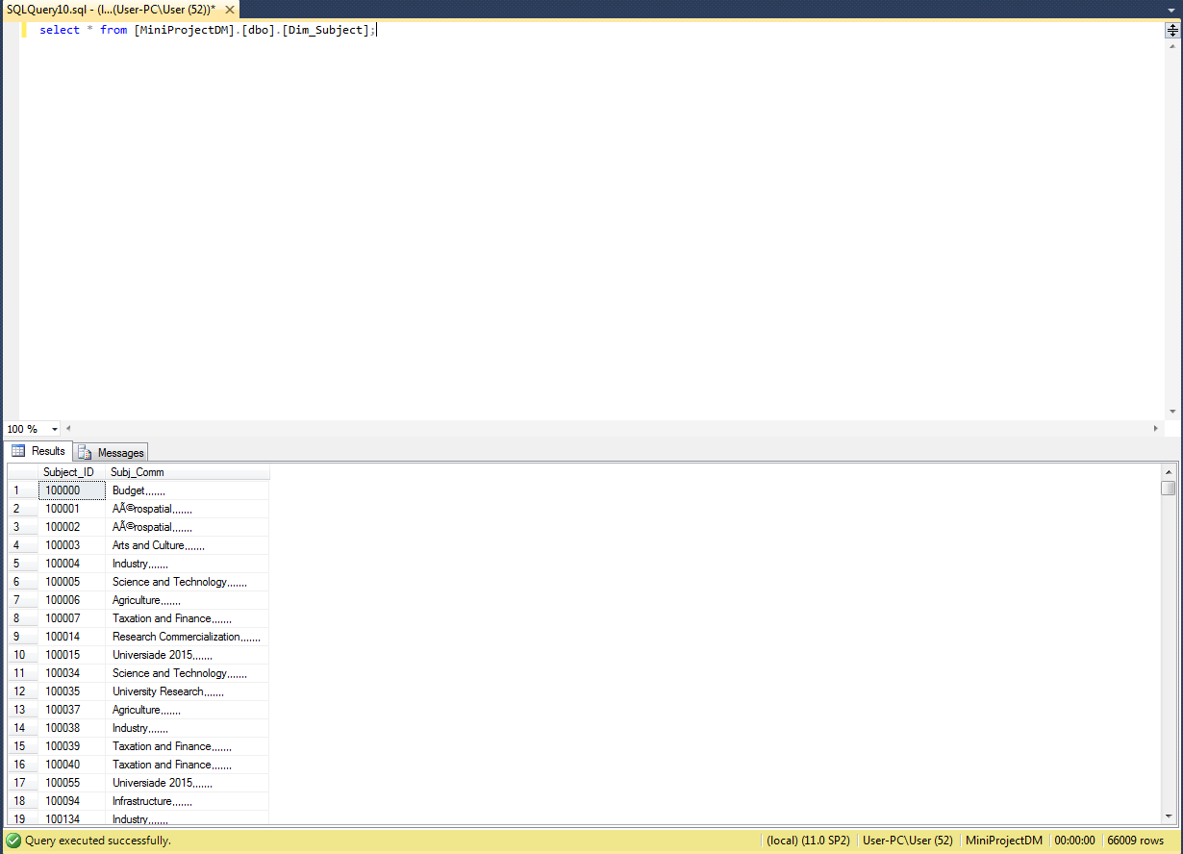

Institution.dtsx

A Snapshot of the SSIS package DataFlow

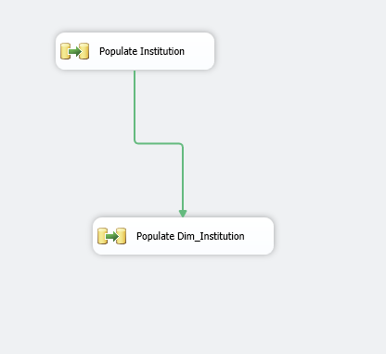

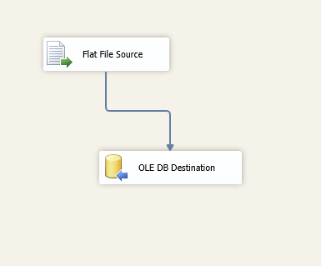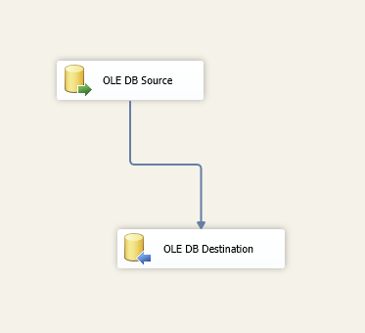

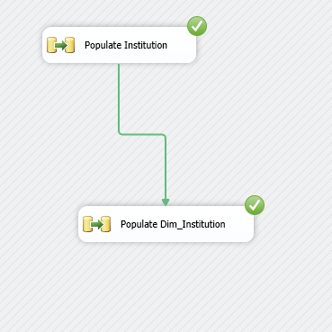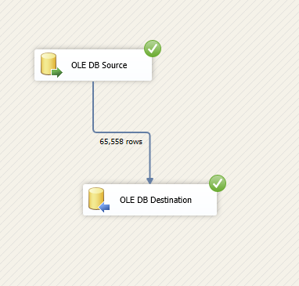

A snapshot of DataFlow MetaData showing the types and sizes of data in SSIS

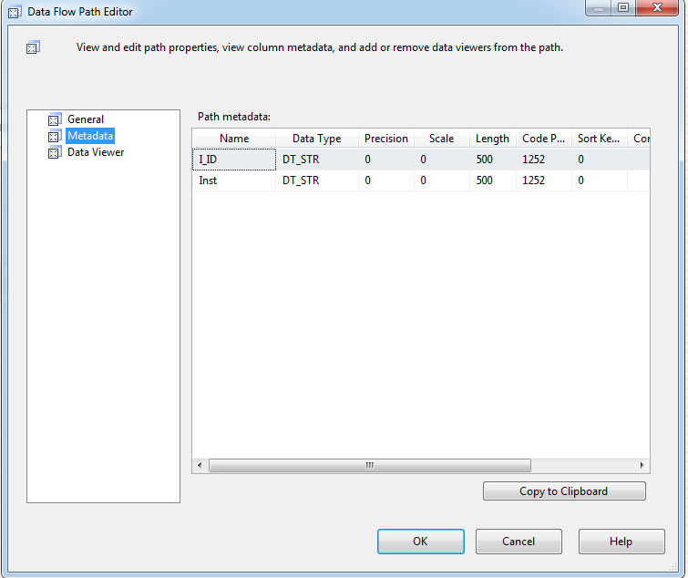

A snapshot of table design view showing the types and sizes of columns in SQL Server

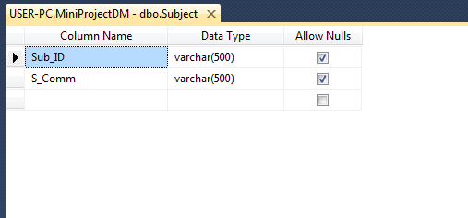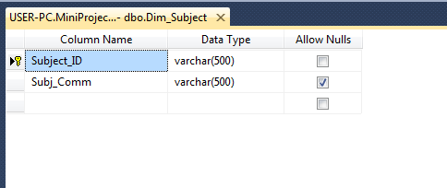

A snapshot of the result of the "Select * from ..." query from your table after successfully running the SSIS package

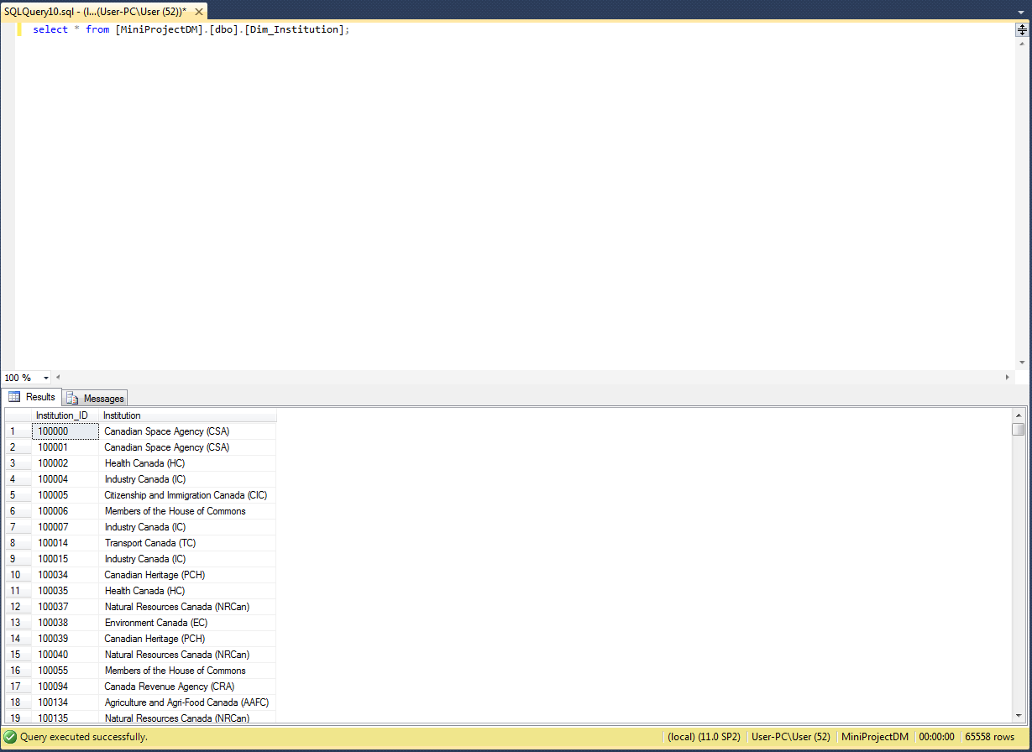

Sender.dtsx

A Snapshot of the SSIS package DataFlow

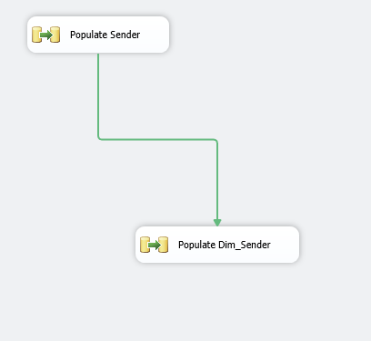

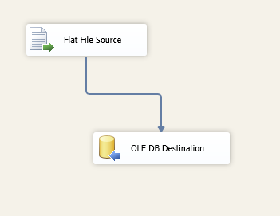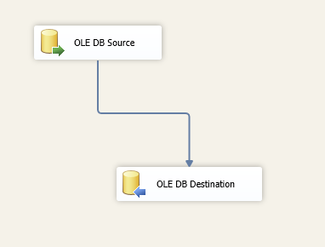

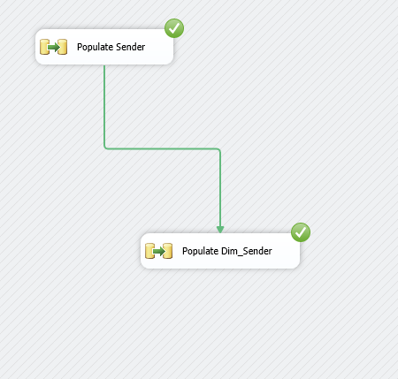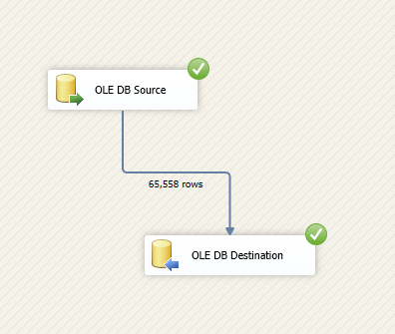

A snapshot of DataFlow MetaData showing the types and sizes of data in SSIS

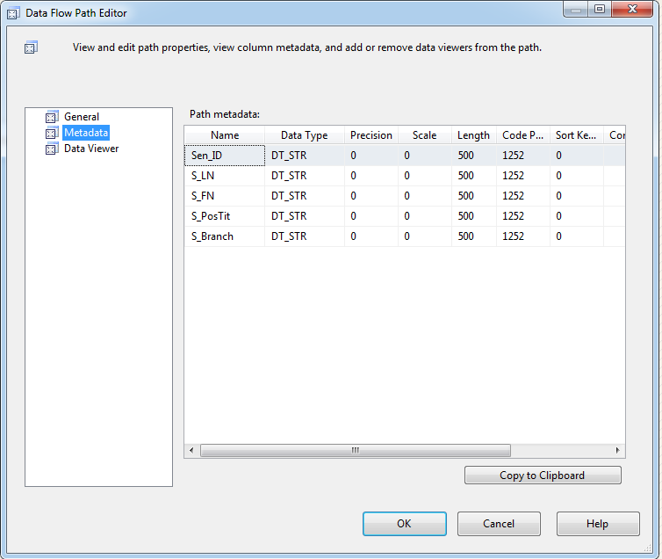

A snapshot of table design view showing the types and sizes of columns in SQL Server

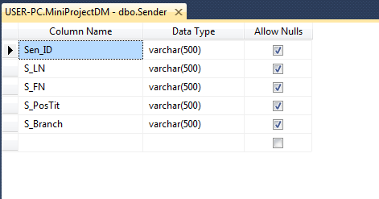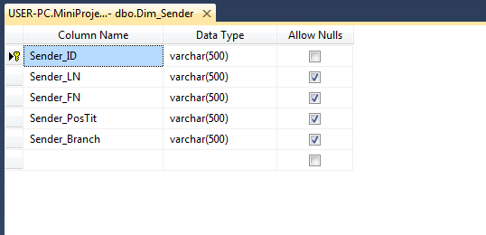

A snapshot of the result of the "Select * from ..." query from your table after successfully running the SSIS package

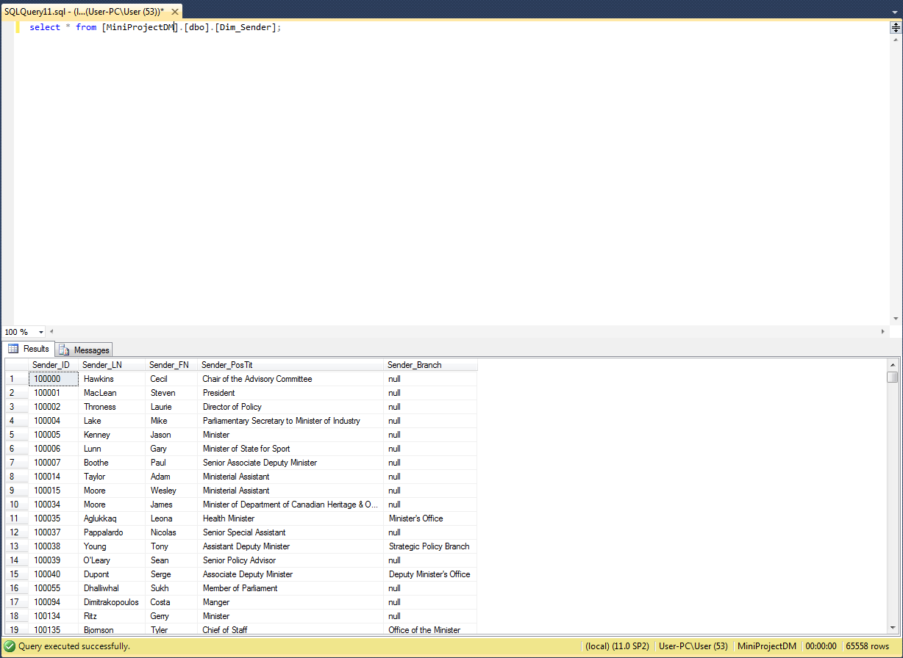

Fact.dtsx

A Snapshot of the SSIS package DataFlow

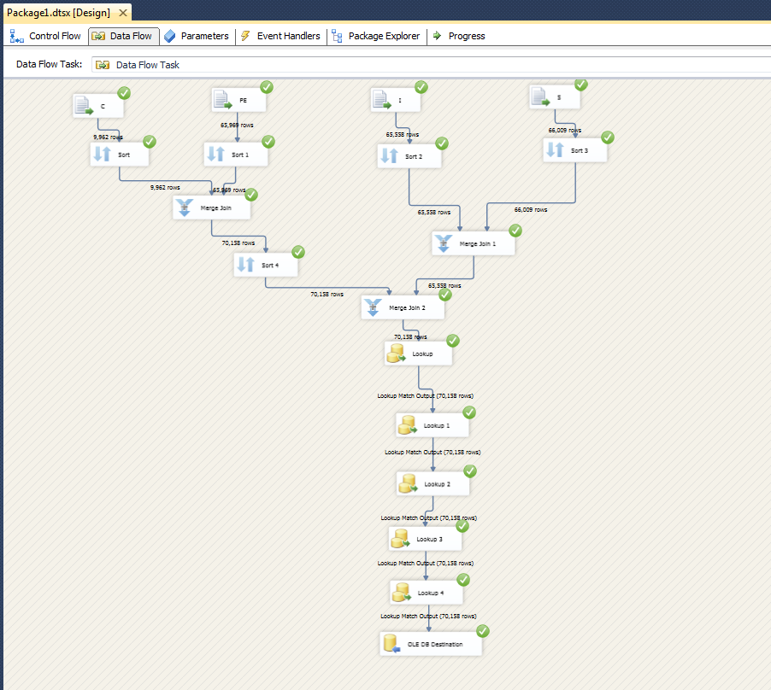

A snapshot of table design view showing the types and sizes of columns in SQL Server

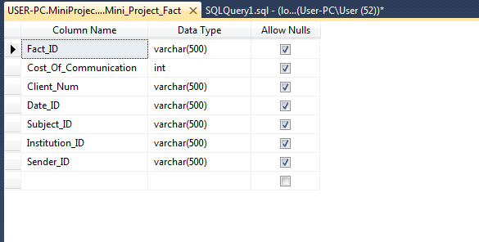

A snapshot of the result of the "Select * from ..." query from your table after successfully running the SSIS package

